Section 14051 Room: NEA 203 Day/Time: M/W 8:55 - 10:20 a.m.
ENGLISH 102: COLLEGE READING AND COMPOSITION II
Hello! I’m Professor Savard.
Welcome to my class.
Please visit me at my office during visit times listed below. Drop by for help or advice, or just to say hi.

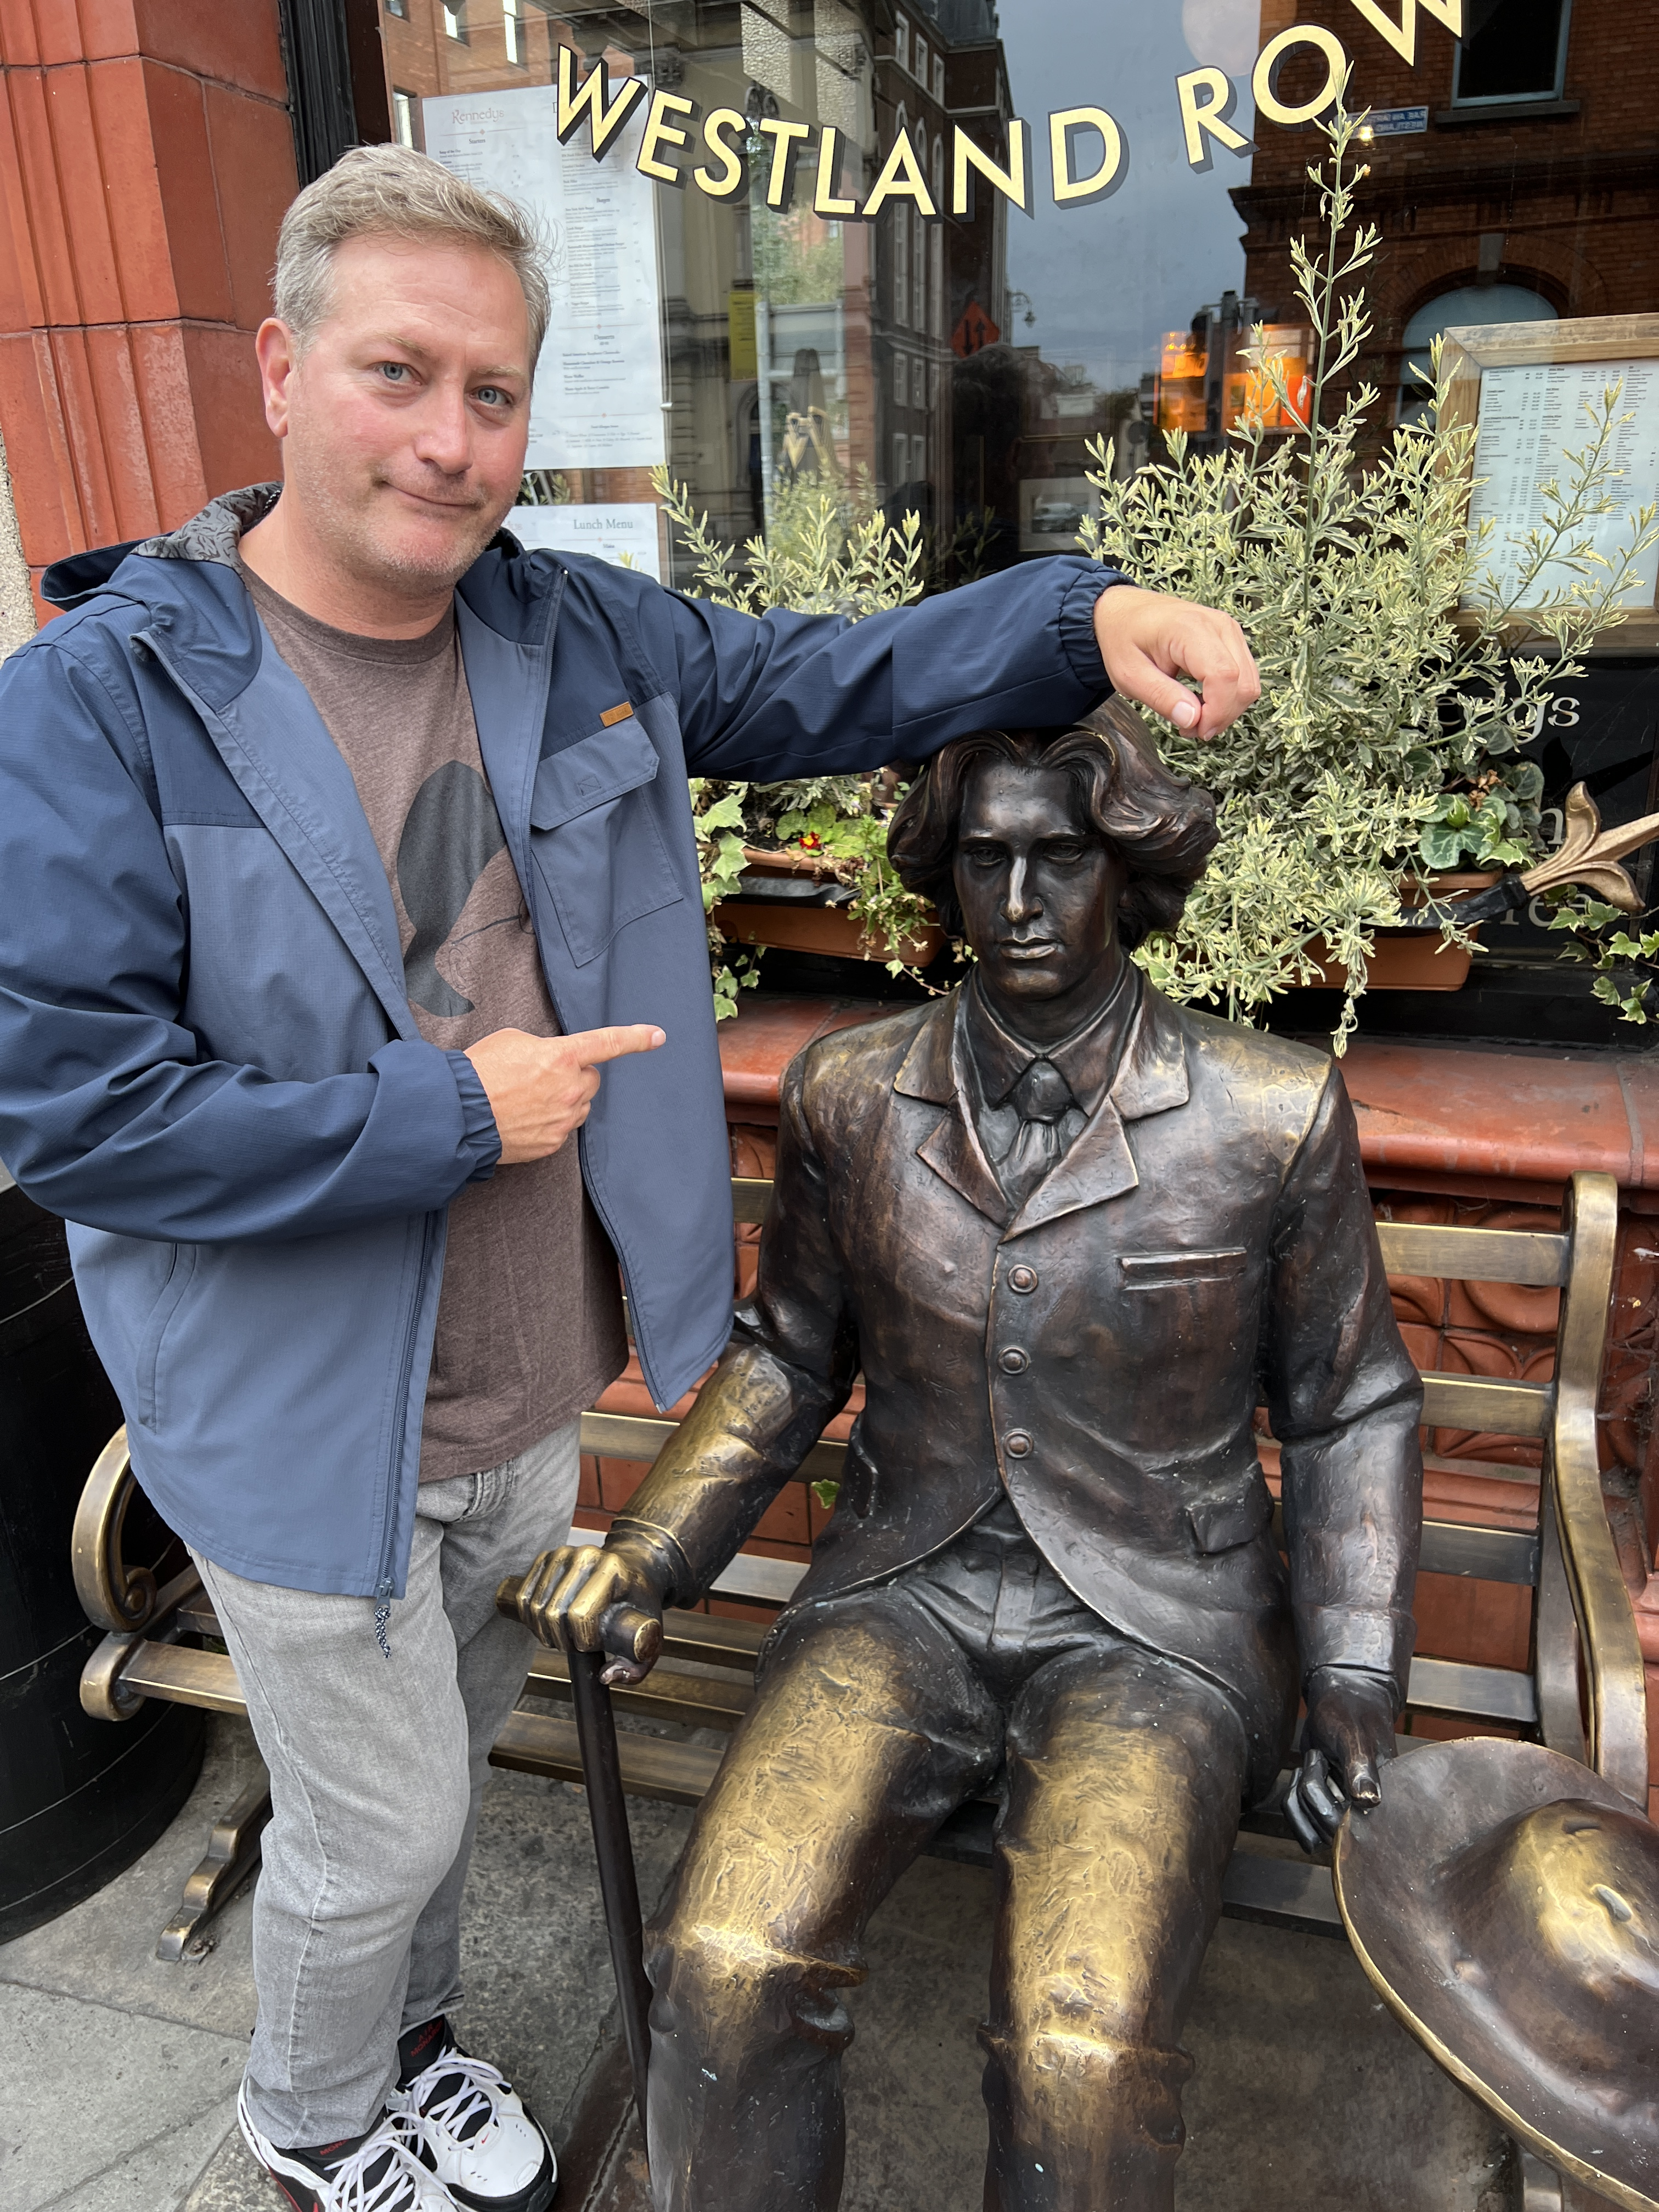
Office Location: NEA 271
Meeting Times: T/TH 12-1:30 p.m. or by appointment. If these times don’t work, let me know. We can make a special appointment time. You can always email me at savardhe@lahc.edu

Required Texts and Materials:
Our class support site is located at:
www.profsavard.weebly.com
This site has digital resources such as the class syllabus, essay assignments, rubric info, grammar help, learning aids, fun links, and more. If you are confused about something, or have lost an important class documents, everything is archived here for download.

Do Androids Dream of Electric Sheep? by Philip K. Dick (Any edition will do, NOT abridged, or a graphic novel)

A Raisin in the Sun, by Lorraine Hansberry

The Importance of Being Earnest, by Oscar Wilde
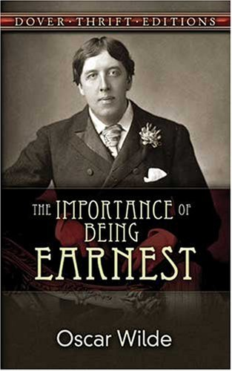

Highly Recommended:
- A personal computer
- Internet access
- Email
- Calendar
- Priorities
- Common Sense
- Responsibility
- Sense of humor

Teaching Philosophy:
I believe that each student has the potential to succeed in my class. I support my students as individuals. I listen to my students and their needs. I try to develop a "mentor" relationship with my students, which means that I’m no better than you, but I just have more experience and expertise in English. I barely passed my freshman English 101 class. As the first one in my family to go to college, I had no idea what I was getting myself into. You probably don’t either, but that’s where I come in. If you are willing to work hard, try new strategies, be flexible, and commit to your goals you can be successful in this class and in college.

Course Description: Welcome to English 102. This course will introduce you to fiction, poetry, and drama. English 110 will improve your critical thinking and writing skills, as well as your ability to write college level essays. Through textual examination, rigorous research, and sound analysis, you will interpret literature critically, crafting argumentative essays in response to the readings. There will be both at-home and in-class writings, all of which will factor into your final grade. Quizzes, journaling, peer editing, spontaneous writing practice, and self-evaluations will supplement our inquiry and essay writing. Prerequisite: English 101 or equivalent with a grade of “C” or better.
Student Learning Outcomes (by the end of this course you will):
- Recognize literary techniques and elements, including but not limited to tone, imagery, symbolism, point of view, and theme, in order to facilitate the analysis of both fiction and nonfiction.
- Develop and demonstrate critical thinking skills through the analysis, interpretation, and evaluation of both nonfiction and fiction.
- Produce a standard MLA format research paper that utilizes and evaluates ideas and information found in a variety of primary and secondary sources, including popular, scholarly, and professional.

How to be Successful in this Class:

Attendance: Attendance is mandatory to pass this course. You must attend all classes and be on time. You are allowed two absences, no questions asked. If you know ahead of time that you will be late or absent on a specific day let me know; this may excuse your tardy or absence. Continued absences or tardiness--regardless of reasons--will adversely affect your grade. Please note that if your absences in “hours” exceed the number of hours the class meets per week, you may be dropped from the class. This class meets 3 hours per week.
Study Skills:
Embrace questioning and inquiry, and realize you don’t know everything, but you should. It’s a tough world out there. Remember that you probably know a great deal already—try to access this information at all times. Follow directions to the best of your ability. The amount of work you will do in this class, and many other college classes, is far more demanding than what you think it will be. Assume that you will need to read everything at least three times: once just to figure out what it is, twice to deal with the vocabulary and strangeness, thrice to start to identify some meaning and structure, and on…To this end you, you must annotate your readings. Write in Your Books! Take Notes! Create Questions! The road to success in this class and in life is asking the right questions. Make yourself into that annoying five-year old who constantly says, “But why?”

Classroom Etiquette:
Respect should be given to your peers and instructor at all times. Treat others as you would like to be treated. Arrive to class on time and stay the entire period. Turn off all cellular phones and sound-emitting electronics upon entering the classroom, unless otherwise given permission. No video or audio recording in class, unless special permission is given.

Title IX (of the 1972 Education Amendments) protects students and staff alike from discrimination based on sex, including Sexual Harassment and Sexual Assault, which are forms of Sexual Misconduct. Under Title IX, all people in the educational environment must be treated equitably, regardless of sex, sexual orientation or expression, and/or transgender identity.

If you have experienced or learned of a possible violation of Title IX and/or would like to know about options, resources (including confidential services), the law, or District policy, please do not hesitate to contact a Title IX Coordinator.

Campus Title IX Co-Coordinators:
Dawn Reid Phone: 310-233-4267 Email: Reid@lahc.edu
Peggy Loewy Wellisch 310-233-4321 Email: Loewywp@lahc.edu
District Title IX Office:
Office for Diversity, Equity, and Inclusion (213) 891-2315 TitleIX@email.laccd.edu

How Your Grade is Calculated:

Participation: Participation is calculated by your attendance in class, preparedness, and your support of the classroom environment. It is a vital component of this class, as most of our time will be spent discussing in class the readings and concepts related to them. Since participation accounts for a hefty chunk of your final grade, I advise you to read actively, jotting down specific questions, reactions, and observations in regard to the texts. You will thus be better prepared to discuss the works in class. It is usually necessary to read an author’s essay at least twice. Additionally, throughout the semester, we will divide ourselves into working groups. The groups will meet in class to tackle grammar exercises or discuss the readings and share and compare observations with the other groups and the professor. Finally, please bring your books, notes, and materials to class every day.

Course Work: All work is due at the beginning of class the day the assignment is listed on the class schedule. If you fail to turn in an assignment on its due date, your final grade will be marked down three full grades for each class day that it is late. This rule applies to all out of class work. There are no make-ups for reading quizzes or any other work done in class. I do not accept any work via email.
Reading Quizzes: Expect to read regularly. You will be quizzed on readings. Quizzes may not be made up. Each quiz is worth 10 points and is open-book, open-note. The quizzes will be varied, but will always necessitate a close reading of the material. Read and re-read and annotate and journal to be prepared.

Journals: For works we read, and related commentaries you will handwrite write informally on a piece of lined paper. These responses may include ideas and analysis of the specific pieces of literature being discussed, or questions you may have about what you’ve read. Please include elements of fiction or theatre from RWL as needed. Give the title of the work at the start of every entry and write at least the following amounts about each type of literature:
Short Story: one page about each story (use the elements of fiction to help guide you)
Novel: one page entry per day’s assigned reading (use elements to guide you)
Theatre: one page per act (use elements to guide you)
Journals are worth 100 points each time they are turned in (4 times with the corresponding essay)

These journal entries are useful in two ways: 1) you will be better prepared for any class discussions we have about the works, 2) you may use your journal on all quizzes. An example of good journaling is available on the class support site under “How to Take Notes.”
Essays: The first two essays are worth 100 points. The third is worth 200 points. Since we will concern ourselves not only with final products, but also with the writing process itself, you will be required to complete prewriting activities and write successive drafts of all out-of-class essays. Further details when essays are assigned. Essays are graded using a rubric. We will discuss and analyze this rubric in great detail throughout the semester. The elements of the rubric
1) Thesis, Process, and Response to Prompt
2) Content Development, Support, and Organization
3) Coherence, Diction, and Style
4) Grammatical soundness (usage, sentence structure, punctuation, spelling, etc.).
5) Critical, Evaluative, and Analytical Elements

You must turn in all outside essays (3) in order to pass this course.
Additionally we will be using Turnitin.com to submit all out-of-class essays. Every essay must be submitted to Turnitin.com by the start of class on the date the essay is due and a final hard copy must be brought to class and turned in. You must do both to turn in an essay properly for a grade. Directions for registration are:
1) Go to http://www.turnitin.com
2) Click on “create an account” and then follow the hyperlink for “student.” (If you have
previously used Turnitin, you can log in with your prior information.)
3) Enter class ID and password: Class ID 42602903 Enrollment key: write
4) Continue with all registration prompts and find your class and section: Eng 102 Spring 2024

How is Your Grade Calculated?
The grading scale for this class is:
90% (900 points) and above = A
80%-89% (800 to 894) = B
70%-79% (700 to 794) = C
60%-69% (600 to 694) = D
59% (590) and below = F

To calculate your grade at any time, simply divide your total points by the total points possible. For example:
900 ÷ 1000 = 90% or an A!
450 ÷ 500 = 90% also an A!

Other Information:
Emergency Procedures: If required to evacuate a classroom or building, students will proceed to a clear and safe area away from the building. Take all personal belongings with you.
Academic Accommodations: Students with verified disabilities requiring accommodations should make a specific request of the instructor in a timely manner, both at the beginning of the semester and at least one week prior to the verified and identified need.
Academic Integrity: Plagiarism occurs when you copy someone else’s words, work, or ideas and pretend that they are your own. Academic dishonesty is a serious offense that carries with it heavy penalties. The bare minimum in terms of punishment for plagiarism is an ‘F’ in the class and a referral to the dean. Other penalties include academic probation and expulsion from Los Angeles Harbor College. Such things tend not to enhance one’s resume/application for either a job or college. For further information, refer to the Los Angeles Harbor College catalog. It is essential that you read and fully understand this statement.
Commitment to Viewpoint Diversity, Mutual Understanding, & Constructive Disagreement
In order to create a classroom environment that supports respectful, critical inquiry through the free exchange of ideas, the following principles will guide our work:
• Treat every member of the class with respect, even if you disagree with their opinion;
• Bring light, not heat;
• Reasonable minds can differ on any number of perspectives, opinions, and conclusions;
• Because constructive disagreement sharpens thinking, deepens understanding, and reveals
novel insights, it is not just encouraged, it is expected;
• All viewpoints are welcome;
• No ideas are immune from scrutiny and debate;
• You will not be graded on your opinions.

Syllabus Changes: The professor reserves the right to make any changes to this syllabus as necessary. If any changes are made, the students will be notified promptly, and sufficient time will be given to adjust to the changes. This syllabus is a contract, and if you remain in this class, you are agreeing to abide by its rules and regulations. This applies to the instructor as well.
Finally: If you have a problem, question, or concern with anything on this syllabus or in this class, please come talk to me! I assure you that approaching me for help or clarification will prove beneficial. My office is in NEA 271, phone extension is 4241, email is savardhe@lahc.edu.
CLASS CONTACTS

Name: ________________________________________________
Phone #: ______________________________________________
Email: ________________________________________________

Name: ________________________________________________
Phone #: ______________________________________________
Email: ________________________________________________

Name: ________________________________________________
Phone #: ______________________________________________
Email: ________________________________________________

Date | Topics & Reading Due (finish before class) | Homework Due or In-Class Assessment | Objectives & Notes
Tue  2/6 | Syllabus
Thu  2/8 | “Happy Endings”  Reading and Writing about Lit. Chapters 3 & 5 | Quiz
Tue  2/13 | “The Lottery” | Quiz
Thu  2/15 | “An Act of Vengeance” | Quiz
Tue  2/20 | “Hills Like White…” | Quiz
Thu  2/22 | “Araby” | Quiz
Tue  2/27 | NO CLASS | NO CLASS
Thu  2/29 | “The Cask of Amontillado” | Quiz
Tue  3/5 | “Cathedral” | Quiz
Thu  3/7 | “Moths” | Quiz
Tue  3/12 | Do Androids Dream of  Electric Sheep?   Do Androids Dream of  Electric Sheep?   Rough Draft of Essay #1 due | Bring one typed copy, all prewriting, and outline to class
Thu  3/14 | Do Androids Dream of  Electric Sheep?   Do Androids Dream of  Electric Sheep?   Final Draft of Essay #1 due  Journals Due | Staple hard copy to rough draft, prewriting, and outline; submit final to turnitin.com | Assignment of Essay #2
Tue  3/19 | Do Androids Dream of  Electric Sheep?   Do Androids Dream of  Electric Sheep?   Do Androids Dream? Chapters 1-3 | Quiz
Thu  3/21 | Do Androids Dream of  Electric Sheep?   Do Androids Dream of  Electric Sheep?   Do Androids Dream? Chapters | Quiz
Tue  3/26 | Do Androids Dream of  Electric Sheep?   Do Androids Dream of  Electric Sheep?   Do Androids Dream? Chapters | Quiz
Thu  3/28 | Do Androids Dream?  Chapters | Quiz
Tue  4/2 | SPRING BREAK | NO CLASS!!!
Thu 4/4 | SPRING BREAK | NO CLASS!!!
Tue  4/9 | Do Androids Dream? Chapters | Quiz
Thu  4/11 | Do Androids Dream? Chapters | Quiz
Tue  4/16 | Rough Draft of Essay #2 due | Bring one typed copy, all prewriting, and outline to class
Thu  4/18 | Final Draft of Essay #2 due  Journals Due | Staple hard copy to rough draft, prewriting, and outline; submit final to turnitin.com | Assignment of Essay #3
Tue  4/23 | RWL Chapter 7  Satire and Theatre | Theatre Worksheet  Due
Thu  4/25 | Library Visit | Quiz
Tue  4/30 | A Raisin in the Sun and  Hansberry | Quiz
Thu  5/2 | A Raisin in the Sun Act 1 | Quiz
Tue  5/7 | A Raisin in the Sun Acts 2 & 3 | Quiz
Thu  5/9 | The Importance of Being Earnest and Wilde | Quiz
Tue  5/14 | The Importance of Being Earnest Act 1 | Quiz
Thu  5/16 | The Importance of Being… Acts 2 & 3 | Quiz
Tue  5/21 | Rough Draft of Essay #3 due | Bring one typed copy, all prewriting, and outline to class
Thu  5/23 | Final Draft of Essay #3 due  Journals Due | Staple hard copy to rough draft, prewriting, and outline; submit final to turnitin.com
Tue  5/28 | Class Final Exam  10:00 a.m.-12:00 p.m. | Papers Returned  Class Final Assignment | Don’t Miss!

